**SCIF SiFi Salem**

**(SSS)**

**Risk Management Policy**

Document history

|  |  |  |  |
| --- | --- | --- | --- |
| Version | Update | By | Comment |
| 1.0 | 21 February 2022 | KC |  |
| 2.0 | 20 February 2023 | KC |  |
| 3.0 | 22 February 2024 | KC |  |
| 4.0 | 20 January 2025 | KC |  |
|  |  |  |  |
|  |  |  |  |

## Contents

1. Introduction 3
2. Risk Architecture 4
   1. Board 4
   2. SCIF 4
   3. Service partners 4
3. Risk Strategy 5
   1. Types of Risks Faced by SSS 6
4. Risk Protocols 6
   1. Risk Process 7
   2. Risk Registry 7

Risk Template 7

Risk Evaluation 8

* 1. Risk Response 9

Exhibit A: SiFi Networks ESG Risk and Opportunities Management Procedure 11

## Introduction

This document defines the SSS Risk Management Policy. It establishes the organization’s Risk Management Framework that includes the Risk Architecture (roles and responsibilities), Risk Strategy (appetite, attitude, and philosophy) and the Risk Management Process and Protocols that the company will follow to ensure the identification, analysis, evaluation, mitigation, and monitoring of risk.

SSS Risk Management Framework

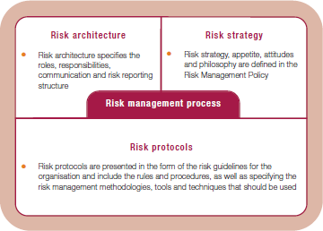

## Risk Architecture

## Board

The Board’s role focuses on risk oversight of management and corporate issues that affect risk at SSS. The Board will focus on the following:

* + 1. Ensure that policies and procedures are developed consistent with SSS’s strategy and risk appetite.
    2. Consider Sustainability factors in evaluating risk and ensure decisions impacting Sustainability related risks, including but not limited to ESG factors (Environmental, Social, Governance) are in alignment with the risk appetite of SSS.
    3. Review management’s implementation of the risk management policies and procedures and making sure that they are resulting in the desired outcome. As part of a formal annual review, the Board will ensure risk policies and procedures remain appropriate and well implemented.
    4. Encourage an organizational culture of risk mitigation that fosters appropriate risk awareness, behaviors and judgments about risk and that ensures that risk-taking beyond the company’s determined risk appetite is recognized and appropriately escalated and addressed in a timely manner.

## SCIF

The Chief Operating Officer (COO) of SCIF US Holdco is ultimately responsible for the implementation and management of the Risk Management Policy and reports regularly to the Board on risk in the business. They are jointly responsible for the development of policies and procedures, as well as the implementation, risk monitoring, and mitigation actions through the Risk Registry.

The SCIF team will:

* + 1. be responsible for presenting to the Board the Risk Registry as part of the board meetings, including highlighting new risks, or changes in the severity of an existing risk;
    2. ensure Sustainability factors are appropriately evaluated when identifying risks and developing mitigation plans;
    3. assist the Board in implementing and maintaining the Risk Culture in all SSS employees and suppliers; and,
    4. will share the main outcomes of the Risk Registry on an annual basis with the main external stakeholders, prior to 30 June of each year in a dedicated session.

## Service partners

In the case where Service partners and strategic suppliers are responsible for the implementation and management of the Risk Management Policy, they will report regularly to the Board on risk in the business.

Where they are responsible for the development of policies and procedures, as well as of the implementation, risk monitoring, and mitigation actions through the Risk Registry, including Sustainability related risks, the company’s Manager, SiFi Networks or its assigned delegate(s) will:

* + 1. Support SCIF on reporting to the Board on the Risk Registry;
    2. Build risk aware culture within the teams;
    3. Agree upon risk management performance targets;
    4. Confirm that Sustainability risks are included in the Risk Registry and risk monitoring processes of service partners;
    5. Ensure implementation of risk improvement recommendations; and
    6. Identify and report changed circumstances / risks.

#### Risk Management responsibilities for internal and outsourced employees:

1. Understand, accept and implement Risk Management processes;
2. Report inefficient, unnecessary, or unworkable controls;
3. Report loss events and near miss incidents; and
4. Co-operate with management on incident investigations.

## Risk Strategy

SSS and its investors have a low appetite for risk and understand the importance of risk management for the performance of the company. The key objective of the risk strategy is to protect and build the performance of the business, following best market practices, environmental regulation and guaranteeing the health and safety of all its employees.

## Types of Risks Faced by SSS

Risk is the effect of uncertainty on the achievement of SSS’s objectives and is measured in terms of likelihood, and impacts. SSS understands risk as events that may have negative influence on the operation or on the company.

By establishing the Risk Management Policy, the company will be able to understand, monitor and mitigate risks to which it is exposed.

The main type of risks that SSS faces have been identified fall in the following categories:

* Operational Risks
* Technological Risks
* Cyber Risks
* Environmental Risks
* Health and Safety Risks
* Regulatory Risks
* Financial Risks
* Market Risks
* External Factors Risks (i.e., War, natural disasters, sabotage, personnel rotation
* Social / Community relations Risks (Public and EMP Opinion)
* Construction Risks
* Sustainability (incl ESG)
* Management
* Insurance
* Planning and Permitting
* Procurement
* Project Management

## Risk Protocols

The Risk Protocols identify the risks SSS is exposed to and put in place actions to mitigate and monitor them. The risk protocols and process are one component of our wider ISO14001, ISO9001 and ISO18001/45001 aligned ESG management system, ensuring we identify, monitor and mitigate any risks.

The figure below shows the risk management process followed at SSS. The risk management process is a live process with constant input from the different stakeholders:

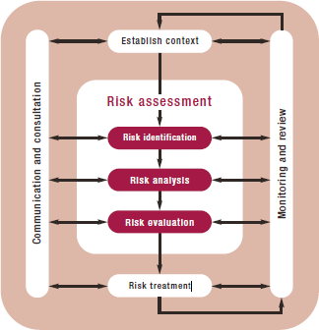

## Risk Process

#### Risk Assessment:

The company and its service partners have in place procedures for the assessment of the different risks which include identification, analysis, and evaluation. Risks will be identified and scored based on qualitative analysis of unplanned events.

Risk identification and analysis establishes the exposure of SSS to risk and uncertainty. This requires an intimate knowledge of the SSS organization, the market in which it operates, the legal, social, political, and cultural environment in which it exists, as well as an understanding of its strategic and operational objectives.

Each risk is evaluated to understand the probability of occurrence and the impact in the business. The evaluation criteria will be explained in section 4.2 Risk Registry.

#### Communication and consultation

The SSS Risk Registry will be included in every board meeting pack. Updates on risks will be highlighted to the Board and/or stakeholders during the monitoring of the risk or the mitigation process.

#### Monitoring and Review

As part of the risk management process, all the risks identified will be monitored and reviewed as per the impact and likelihood of each of them. Monitoring and reviewing may result on a risk registry

update and immediate communication to the Board in those cases where the likelihood or impact is high.

## Risk Registry

The Risk registry will include a list of all the risks identified by the project team. It will include the likelihoodof each Risk arising as well as the potential impact. Each Risk will have corresponding mitigation actions and/or monitoring procedures. The Board may identify risks that will require additional reporting, depending on severity of impact. The Risk Registry will be updated and presented to the Board of Directors at every board meeting and any changes adopted and minuted by the Board.

#### Risk Template

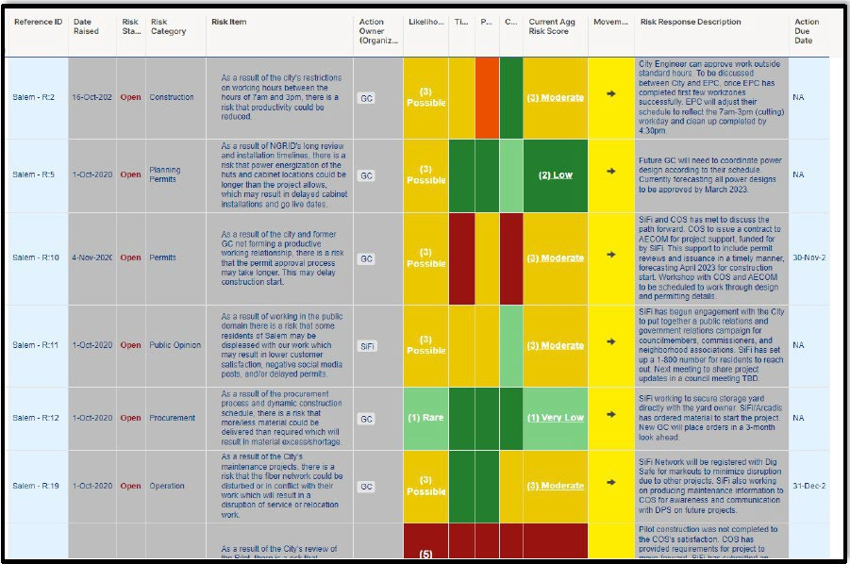An example format can be seen in the following Image:

The following defines the Risk Register columns:

|  |  |
| --- | --- |
| Registry Item | Description |
| Ref. no | Risk number |
| Project Name | Name of the Project |
|  |  |
| Risk Status | Is the risk open or closed |
| Risk Category | Construction, Planning Permits, Health and Safety, Permits, Public Opinion, Procurement, Operation, Shelters, Natural  Disaster, Schedule, Mobilization, Insurance, Finance |
| Risk Item | Description of the identified risk |
| Action Owner | Party responsible for managing the identified risk. Could be individual or organization |

|  |  |
| --- | --- |
| Action Due Date | The date mitigation actions must be taken according to  mitigation plan. A due date is only required when the risk response is “Mitigate” |
| Likelihood | Frequency of the risk to occur |
| Cost Impact | Level of impact on cost to the Project |
| Performance / Quality Impact | Overall quality impact on the project |
| Time Impact | Risk to overall project schedule |
| Current Agg Risk Score | Overall score of the identified risk where in 1 is the lowest  and 4 is the highest |
| Movement | Indicates whether risk score has increased, decreased, or  remained the same over the last 8 weeks |
| Risk Response | Transfer, Mitigate, Accept, or Monitor |
| Risk Response Description | How the responsible party will take action or mitigate the identified risk |
| Secondary Effect | Indirect consequences of a risk or follow-on impacts to the risk identified |

#### Risk Response

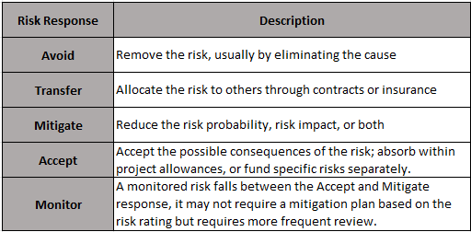Risk handling involves developing specific, discrete responses to address each risk and reduce overall project uncertainty. If the identified risks are unacceptable, seek ways of preventing or reducing those risks and create fallback plans. In some cases, risks can be eliminated while other risks are completely external to the project, presenting little scope for reduction. See Risk Response Structure:

#### Risk Evaluation

The Risk evaluation is a very important step in the process to understand how the different risks are affecting the organization. Each risk will have a probability and an impact score. The scoring criteria is detailed below.

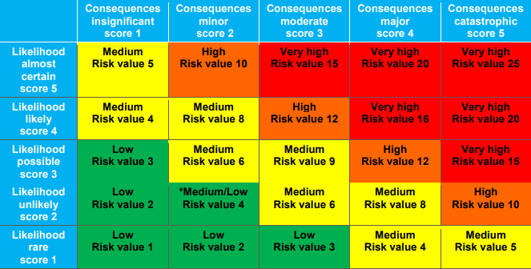

The Probability / Impact Matrix (PIM) above is a useful tool for assessing risk. A risk’s likelihood can be expressed as a qualitative score (e.g. 1 through 5, where 5 is highly likely) which equates to a percentage likelihood as shown below:

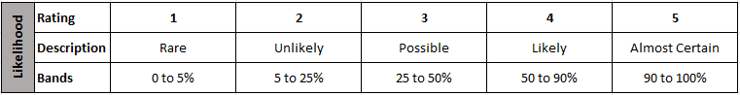

A risk’s impact is similarly expressed using as a 1-5 score as shown below. The principle impacts are for cost and time and the risk scores equate to bands of cost and time impact. Additional impact scores can be used as appropriate, for example quality, reputation, legal. Risks are scored according to their ‘current’ likelihood and impact, i.e. the team’s opinion of the likelihood of occurrence and what the impact will be based on what is known now.

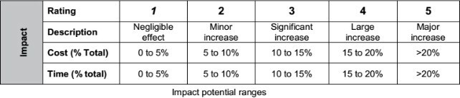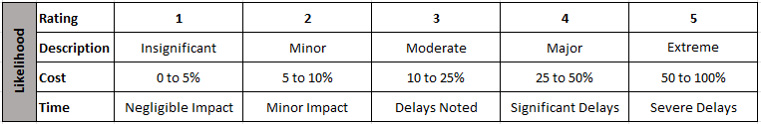

Exhibit A

SiFi Networks ESG Risk and Opportunities Management Procedure

SiFi-ESG-PRD001 - ESG Risk Management Procedure



SiFi Networks

ESG Risk and Opportunities Management Procedure

Doc REF: SiFi-ESG-PRD001

Contents

1. Documentation standards 5
   1. Definitions 5
   2. Nomenclature 5
2. Preface 6
   1. Introduction 6
   2. Scope 6
3. ESG Risk Assessment 7
   1. Purpose 7
   2. Process Overview 7
4. Conduct Risk Assessment 8
   1. Identification of issues and opportunities 8
   2. Determine Risks 9
      1. Inherent Risk 9
      2. Residual Risk 9
      3. Actual Risk 9
      4. Determine Consequences 9
      5. Determine Likelihoods 11
      6. Risks 12
5. Risk Analysis & Treatment 12

Tables

Table 1 - Issue or Opportunity Categorisation 8

Table 2 - Issue or Opportunity Consequences 10

Table 3 - Likelihood of Issues or opportunities 11

Table 4 - Level of Risk 12

Table 5 - Level of Risk - Definition 12

Changelog

This table captures the high-level changes for authored versions. See any relevant OARs, Release and Change Notes for details of changes.

|  |  |  |  |
| --- | --- | --- | --- |
| **Rev** | **Date** | **Author** | **Comments** |
| V1.0 | 2023-12-01 | Gary Scothern | First Issue |
|  |  |  |  |
|  |  |  |  |

# Document approval

Before the document can be considered binding, the following parties should provide their approval.

|  |  |  |  |  |  |
| --- | --- | --- | --- | --- | --- |
| **Role** | **Name** | **Designation** | **Affiliation** | **Signature** | **Date** |
| Author | Gary Scothern | Operations Security  Director | SiFi Networks |  |  |
| Approver | Ben Bawtree-  Jobson | CEO | SiFi Networks |  |  |
| Approver | James Courtenay-  Evans | CFO | SiFi Networks |  |  |
| Reviewer | Rich Adams | COO | SiFi Networks |  |  |
| Reviewer | Jason Manley | CTO | SiFi Networks |  |  |
| Reviewer | Peter Neda | General Counsel | SiFi Networks |  |  |

# Registered and affected parties

Should this document be revised or modified, the following parties should be notified.

|  |  |  |
| --- | --- | --- |
| **Name** | **Designation** | **Affiliation** |
|  |  |  |

# Reference documents

The following documents are referenced in this document and are listed for convenience. In the event of a conflict between the contents of the referenced document and this document, this document shall take precedence.

|  |  |  |
| --- | --- | --- |
| **Author(s)** | **Title** | **Number** |
| Gary Scothern | ESG Risk Management Record | SiFi-ESG-TMP001 |

# Documentation standards

### Definitions

The term SiFi Networks refers to all SiFi Networks entities and includes SiFi Networks America Ltd, SiFi Networks America LLC and all SiFi Networks’ City LLCs.

Wherever in this policy the term 'staff' (or 'SiFi Networks staff') is mentioned, it means all SiFi Networks employees including contractors and temporary staff.

### Nomenclature

In keeping with ISO practices for requirements definitions, we adopt the following meanings in this document:

*Shall* (and its negative *shall not*) is used to indicate a requirement that is contractually binding, meaning it is to be implemented by the design team and its implementation verified.

*Will* (and its negative *will not*) is used to indicate a statement of fact or declaration of purpose and is not subject to verification.

*Should* (and its negative *should not*) is used to indicate a recommendation, goal, or non- mandatory provision. This indicates a goal which is to be addressed by the design team but is not formally verified.

*May* (and its negative *may not*) is used to indicate a non-mandatory suggestion or permission.

# Preface

### Introduction

Environmental, Social, and Governance (ESG) related issues as well as the impacts they create, the opportunities they provide and risks that they generate are becoming more and more relevant for businesses. SiFi Networks recognises the importance of ESG risks and that managing ESG risks is just as important as opportunities in the pursuit of sustainable growth and transitioning towards a more ESG friendly environment.

This procedure sets out SiFi Networks approach to identify and evaluate ESG risks within the organisation.

### Scope

This procedure is mandatory for all SiFi Networks staff who are responsible for the assessment of ESG risk. It should be understood and used by them as necessary to perform their duties.

# ESG Risk Assessment

### Purpose

This procedure provides the guidance to perform a risk assessment in order to identify and evaluates issues or opportunities that affect the environmental, social and governance aspects of SiFi Networks business.

### Process Overview

The objective of this procedure is to produce a list of environmental, social and governance risks and opportunities that can be prioritised and used to inform risk response decisions. To accomplish this objective, SiFi Networks will analyse issues or opportunities, consequences, and likelihoods.

Conducting the risk assessment will include the following specific tasks:

* Identify the issues and opportunities that may be relevant to SiFi Networks.
* Determine the consequences resulting from the materialisation of the issues and opportunities.
* Determine the likelihood that the issues and opportunities would materialise.
* Determine risks as a combination of the consequences and likelihood of the issues and opportunities.

The specific tasks are presented in a sequential manner for clarity. However, in practice, some iteration among the tasks is both necessary and expected.

# Conduct Risk Assessment

### Identification of issues and opportunities

This step is intended to Identify issues or opportunities that may be presented to SiFi Networks. Issues identified should first be categorised from the table below:

*Table 1 - Issue or Opportunity Categorisation*

|  |  |  |
| --- | --- | --- |
| **Environmental** | **Social** | **Governance** |
| Air pollution | Child labour | Audit committee structure/ independence |
| Biodiversity and habitat | Community development | Board composition |
| Contaminated land | Customer satisfaction | Board ESG oversight |
| Energy | Diversity, Equity and Inclusion | Bribery and corruption |
| Greenhouse gas emissions | Employee engagement | Compensation committee structure/independence |
| Hazardous substances | Forced or compulsory labour | Conflicts of interest |
| Light pollution | Freedom of association | Cybersecurity |
| Material sourcing and resource efficiency | Health and safety: community | Data protection and privacy |
| Net zero | Health and safety: contractors | Delegating authority |
| Noise pollution | Health and safety: employees | Executive compensation |
| Physical risk | Health and safety: supply chain | Fraud |
| Waste | Health and safety: users | Independence of board chair |
| Water inflows/withdrawals | Labour standards and working conditions | Lobbying activities |
| Water outflows/discharges | Local employment | Political contributions |
|  | Social enterprise partnering | Shareholder rights |
|  | Stakeholder relations | Whistle-blower protection |

A more detailed description of the issue or opportunity should also be recorded. The timeframe of issues or opportunity should also be identified.

The following options are provided:

* Past – Legacy issues or opportunities that are still having an impact
* Current – Ongoing issues or opportunities that are still having an impact
* Future – Possible issues or opportunities that could have an impact

Any issues and opportunities identified should be recorded in the form SiFi-ESG-TMP001 - ESG Risk Management Record.

### Determine Risks

The following steps are intended to determine the risk to SiFi Networks from issues or opportunities of concern.

These steps will need to be repeated considering different factors in order to determine the following three levels of risk:

* Inherent Risk
* Residual Risk
* Actual Risk

#### Inherent Risk

Inherent risk represents the amount of risk that exists in the absence of controls.

Likelihoods and consequences for calculating inherent risks should be identified considering the following factors:

* + - 1. The consequences that would result from the events.
      2. The likelihood of the events occurring.

#### Residual Risk

Residual risk is the amount of risk that remains after controls are accounted for.

Likelihoods and consequences for calculating residual risks should be identified considering the following factors:

* + - 1. The consequences that would result from the events.
      2. The likelihood of the events occurring.
      3. Any mitigating factors and controls that may be implemented.

#### Actual Risk

Actual risk is the amount of risk that remains due to implementation gaps within the planned controls.

Likelihoods and consequences for calculating actual risks should be identified considering the following factors:

* + - 1. The consequences that would result from the events.
      2. The likelihood of the events occurring.
      3. Any mitigating factors and controls that may be implemented.
      4. Any gaps in the mitigating factors and controls implemented.

#### Determine Consequences

The step is intended to determine the consequences from issues or opportunities.

The impact of each identified issue or opportunity should be assessed. The definitions of consequences provided in Table 2 (Issue or Opportunity Consequences) should be used as a guide in this assessment.

It is possible to assign a 'negative' score to those consequences that are beneficial.

SiFi-ESG-PRD001 - ESG Risk Management Procedure

*Table 2 - Issue or Opportunity Consequences*

|  |  |  |  |  |  |  |  |
| --- | --- | --- | --- | --- | --- | --- | --- |
|  | | **Description of Consequences** | | | | | |
| **Score** | **Consequence** | **Financial** | **Media & Regulators** | **Health & Safety** | **Environmental** | **Public Relations** | **Service** |
| -1 | **Positive** |  |  |  | * Positive environmental improvement, reduced environmental impact | * Good for public relations |  |
| 1 | **Low (Negligible)** | * Loss <$50, 000 | * Low level interest from local media or regulators | * Low level short term symptoms with no medical treatment | * Noticeable impact on-site only * Small-scale use of renewable resources * Negligible environmental damage | * Public concern restricted to local complaint | * Inconsequential disruption |
| 2 | **Medium-low (Minimal)** | * Loss $50, 000 -   $100,00 | * A small number of enquires local media or regulators | * Injury with restricted or lost time days   < 5 days | * Noticeable environmental impact limited to a small area * Moderate use of non- renewable resources or large-scale use of other resources * Large-scale use of renewable resources | * Adverse public concern with a small number of complaints | * Loss of service delivery for 1 week |
| 3 | **Medium (Moderate)** | * Loss $100,000 -   $250,000 | * Adverse public concern and attention from national media <1 week | * Injury with restricted or lost time days   > 5 days | * Moderate environmental impact within and outside the facility but no lasting environmental damage * Large scale use of non- renewable resources * Hazardous substances releases with 1/2 mile effect | * Adverse public concern with a large number of complaints | * Loss of service delivery for > 1-4 weeks |
| 4 | **Medium-high (Severe)** | * Loss $250,000 -   $500,000 | * Serious national, media, government or regulator involvement that requires sustained effort for > 3 months | * Single fatality or permanent impairment to < 10 people | * Damage to land beyond the facility boundary, reversible * Serious toxic effect on beneficial or protected species in the area | * Public confidence affected for a period of up to 6 months | * Loss of service delivery 1 – 3 months |
| 5 | **High (Catastrophic)** | * Loss > $500,000 | * Crisis event with serious national, media, government or regulator involvement that requires sustained effort for > 3 months | * Single fatality or permanent impairment to > 10 people | * Severe widespread environmental damage, irreversible | * Public confidence affected for a period > 6 months | * Loss of service delivery for > 3 months |

SiFi-ESG-PRD001 - ESG Risk Management Procedure

#### Determine Likelihoods

This step is intended to determine the likelihood that issues or opportunities of concern will result in the identified consequences.

The scale of likelihood provided in Table 3 (Likelihood of Issues or opportunities) should be used in this determination.

*Table 3 - Likelihood of Issues or opportunities*

|  |  |  |
| --- | --- | --- |
| **Score** | **Likelihood** | **Description** |
| 1 | **Low (Rare)** | Risk/hazard may be present during this task in exceptional circumstances therefore would be rare or the risk can occur under extreme conditions more than every 40 years. |
| 2 | **Medium-low (Unlikely)** | Risk/hazard unlikely to occur on most occasions when this task is carried out or is considered likely to occur once in 11 - 40yrs. |
| 3 | **Medium (Possible)** | Risk/hazard could possibly occur on some occasions when task is carried out or is considered likely to occur at least once in 10yrs. |
| 4 | **Medium-high (Likely)** | Risk/hazard is likely to occur on occasions when task is carried out or is considered likely to occur at least once in one year. |
| 5 | **High (Rare)** | Risk/hazard almost certain to occur every time task is carried out or is expected to occur multiple times throughout one year. |

SiFi-ESG-PRD001 - ESG Risk Management Procedure

#### Risks

This step is intended to determine the level of risk to SiFi Networks from issues or opportunities of concern.

In this step, results should be compiled of each of the preceding steps and determine the degree of risk to SiFi Networks from each identified issue or opportunity.

Table 4 (Level of Risk) provides a matrix of the combined values of table 2 & table 3 to determine the overall level of risk.

Table 5 (Level of Risk - Definition) provides a definition for the risk levels that should be used in this assessment. These levels represent the assessed degree or level of risk to which SiFi Networks would be exposed if a given issue or opportunity were to materialise.

*Table 4 - Level of Risk*

|  |  |  |  |  |  |  |
| --- | --- | --- | --- | --- | --- | --- |
|  | | **Likelihood** | | | | |
| **Low** | **Medium-low** | **Medium** | **Medium-high** | **High** |
| **Consequences** | **Positive** | **-1** | **-2** | **-3** | **-4** | **-5** |
| **Low** | 1 | 2 | 3 | 4 | 5 |
| **Medium-low** | 2 | 4 | 6 | 8 | 10 |
| **Medium** | 3 | 6 | 9 | 12 | 15 |
| **Medium-high** | 4 | 8 | 12 | 16 | 20 |
| **High** | 5 | 10 | 15 | 20 | 25 |

*Table 5 - Level of Risk - Definition*

|  |  |  |
| --- | --- | --- |
| **Risk Score** | **Risk Rating** | **Risk Rating Description** |
| **< 1** | **Positive** | Positive impact. Extend activities as appropriate |
| **1 - 4** | **Acceptable** | Low impact. No further action, review at regular intervals. |
| **5 - 9** | **Adequate** | Noticeable impact. Look to improve at next review |
| **10 - 16** | **Tolerable** | Potential for moderate impact. Look to improve within specified timescale. |
| **17 - 25** | **Unacceptable** | Potential for high impact. Consider stopping the activity and make immediate improvements. |

# Risk Analysis & Treatment

The three levels of risk (Inherent, Residual and Actual) identified for each threat event should then be used to determine, analyse, prioritise, and create an action plan to address any gaps in mitigating controls in order to meet ESG objectives.